**FIU 2017 Spring**

**ESI 6455**

**Advanced Engineering Project Management**

**Yezehao Huai (5965823)**

**Chapter 8 HW: P283 E4**

**4.* You have prepared the following schedule for a project in which the key resources is a tractor. There are three tractors available to the project. Activities A and D require one tractor to complete while activities B, C, E and F require 2 tractors.**

**Develop a resource-constrained schedule in the loading chart that follows. Use the parallel method and heuristics given. Be sure to update each period as the computer would do. Record the early start (ES), late finish (LF) and slack (SL) for the new schedule.**

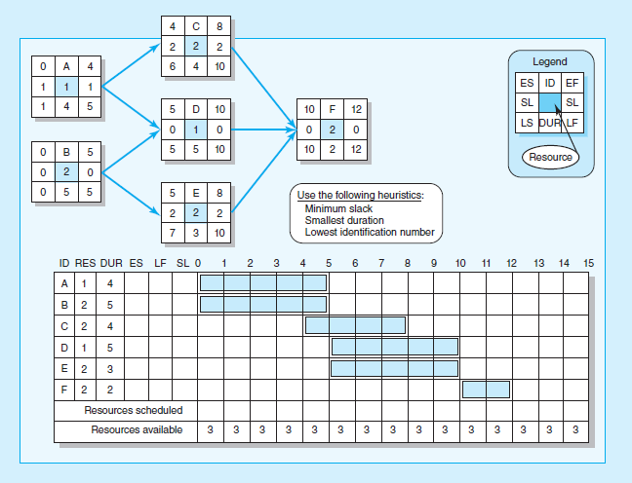

|  |  |  |  |  |  |  |  |  |  |  |  |  |  |  |  |  |  |  |  |  |  |
| --- | --- | --- | --- | --- | --- | --- | --- | --- | --- | --- | --- | --- | --- | --- | --- | --- | --- | --- | --- | --- | --- |
| ID | RES | DUR | ES | LF | SL 0 1 2 3 4 5 6 7 8 9 10 11 12 13 14 15 | | | | | | | | | | | | | | | | |
| A | 1 | 4 | 0 | 5 | 1 | 1 | 1 | 1 | 1 | - |  |  |  |  |  |  |  |  |  |  |  |
| B | 2 | 5 | 0 | 5 | 0 | 2 | 2 | 2 | 2 | 2 |  |  |  |  |  |  |  |  |  |  |  |
| C | 2 | 4 | 5 | 9 | 0 |  |  |  |  | x | 2 | 2 | 2 | 2 |  |  |  |  |  |  |  |
| D | 1 | 5 | 5 | 12 | 2 |  |  |  |  |  | 1 | 1 | 1 | 1 | 1 |  |  |  |  |  |  |
| E | 2 | 3 | 9 | 12 | 0 |  |  |  |  |  | x | x | x | x | 2 | 2 | 2 |  |  |  |  |
| F | 2 | 2 | 12 | 14 | 0 |  |  |  |  |  |  |  |  |  |  | x | x | 2 | 2 |  |  |
| Resources scheduled | | | | | | 3 | 3 | 3 | 3 | 2 | 3 | 3 | 3 | 3 | 3 | 2 | 2 | 2 | 2 |  |  |
| Resources available | | | | | | 3 | 3 | 3 | 3 | 3 | 3 | 3 | 3 | 3 | 3 | 3 | 3 | 3 | 3 |  |  |